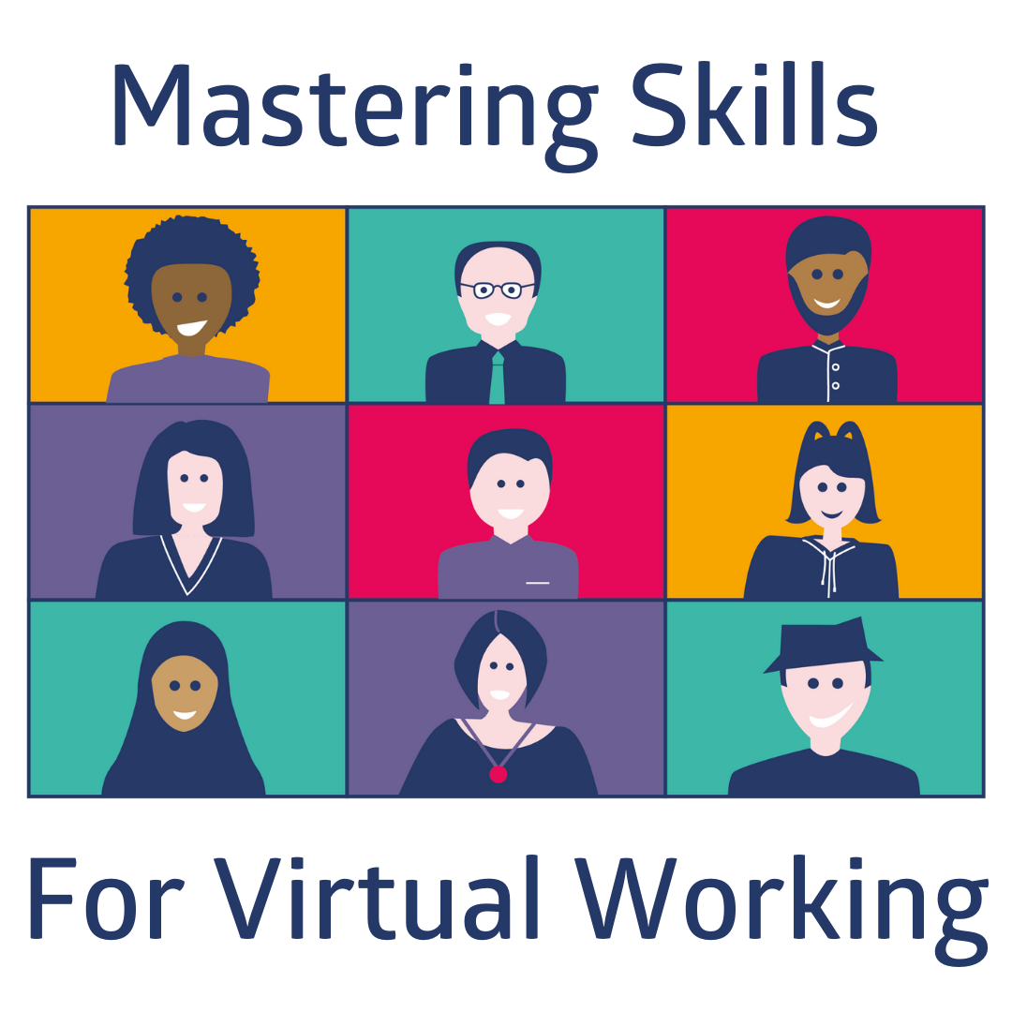

EMPLOYER PACK

Introduction:

In a post Covid world we are facing the reality of the continuation of working virtually, yet young people leaving school have not all had the opportunity of valuable exposure to what this is like. In response to this a small group of employers and volunteers came together to create insight for young people ‘Mastering Skills for Virtual Working’.

The insight aims to build awareness and skills for young people close to entering the world of work. Framing the positives of working virtually alongside the expectations for all involved and the critical element of wellbeing.
The insight has been broken down into three component parts designed to provide young people with the information and tools to help them:
- Become more informed about the changes to the world of work as a result of virtual working.
- Develop the skills they will need to work virtually.
- Be ready for working virtually
- Ensure young people consider wellbeing when working virtually

Delivery Options:

There are three methods of delivery a school/college can choose from, this offers more equity of access for young people
- Educator led session
- Employer led live session – Educators book through Marketplace or DYW Live for a national session
- Pre-recorded employer led session – This can be access on our YouTube Channel – available June 2021

Employer Led Session:

We believe an employer led live session gives the opportunity for the young people to engage in more meaningful conversation with an employer who is working/has worked virtually.

This pack gives you the tools and links you need to deliver the session virtually or in a school environment when possible.

The three component parts are:
- An introduction to Working Virtually – Suggested 30 - 40 minutes (If breakouts are enabled, 15 – 20 if broadcasting without activities)
- On Boarding and Working Virtually – Suggested 30 - 40 minutes (If breakouts are enabled, 15 – 20 if broadcasting without activities)
- Wellbeing – Suggested 30 - 40 minutes (If breakouts are enabled, 15 – 20 if broadcasting without activities)

What you need:

All resources can be accessed at https://www.dyw.scot/mastering-skills-for-virtual-working.html

This includes:

- Slide deck with delivery notes
- Handout for young people
- Videos for use to bring the session to life (Also embedded in the slide deck)
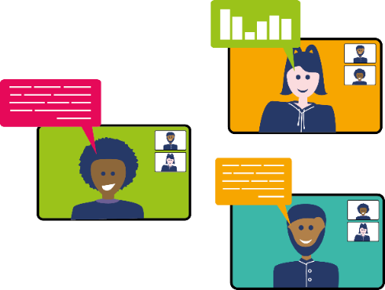
- Mind Tools resource website for additional tools to support delivery or additional reading/viewing between sessions where possible (Password will be provided on request from your DYW Coordinator/Regional Group) and a handout showing resources mapped to the component parts of the session

Top Tips:

- Post your offer to deliver this session on Marketplace
- As an employer delivering live you may wish to use your experiences to bring aspects of the session to life.
- You could involve young people from your organisation to deliver the session and offer their perspective instead of using the videos provided for the first and last session components.
- The video for the ‘On Boarding and Working Virtually’ component does not need to be used as you bring the employer voice to this. If used, you can summarise the slides much more quickly after the video has played, reflecting on the key points made by Halima in the video.
- If delivering to one group in one school we suggest a discussion with the educator pre session to ensure the technology will work and to cover off any questions you may have like how the educator will support the breakout session element.
- If you choose to broadcast the delivery, this involves less interaction and changes the breakout sections to involve young people posting comments on the stream which will reduce the time required for delivery, this may mean you can do this in one 45 minute broadcast.

Any questions please contact your DYW Regional Group - https://www.dyw.scot/regions.html

