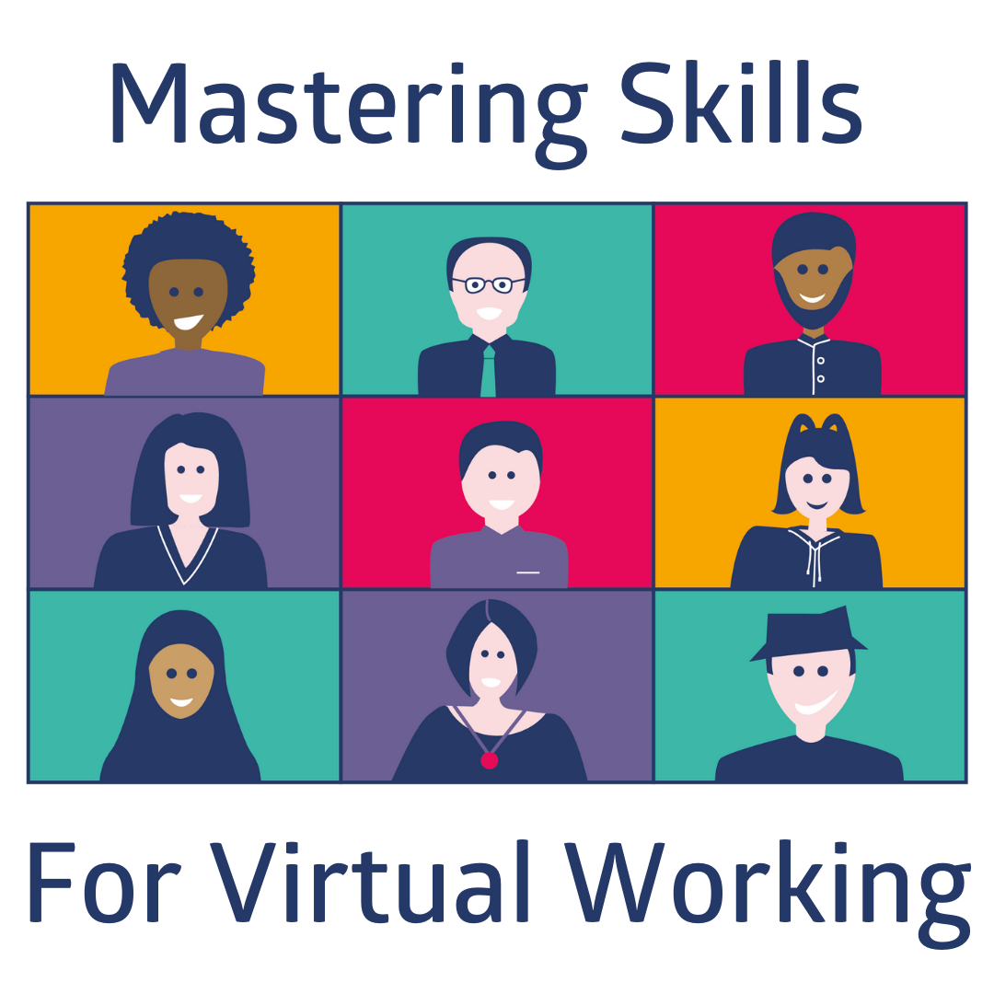

EDUCATOR PACK

Introduction:

In a post Covid world we are facing the reality of the continuation of working virtually, yet young people leaving school have not all had the opportunity of valuable exposure to what this is like. In response to this a small group of employers and volunteers came together to create insight for young people ‘Mastering Skills for Virtual Working’.
The insight aims to build awareness and skills for young people close to entering the world of work. Framing the positives of working virtually alongside the expectations for all involved and the critical element of wellbeing.
The insight has been broken down into three component parts designed to provide young people with the information and tools to help them:
- Become more informed about the changes to the world of work as a result of virtual working.
- Develop the skills they will need to work virtually.
- Be ready for working virtually
- Ensure young people consider wellbeing when working virtually

Delivery Options:

There are three methods of delivery you can choose from
- Educator led session – You deliver using the details in this pack
- Employer led live session – You can book through Marketplace or DYW Live when available
- Pre-recorded employer led session – This can be access on our YouTube Channel – available June 2021

Educator Led Session:

This pack gives you the tools and links you need to deliver the session in your school.
The session delivery timings can be tailored to suit your audience. The three component parts are:
- An introduction to Working Virtually – 30 minutes
- On Boarding and Working Virtually – 30 minutes
- Wellbeing – 30 minutes

What you need:

- Slide deck with notes
- Handout for young people
- Videos for use to bring the session to life (Also embedded in the slide deck)
- Mind Tools resource website for additional tools to support delivery or additional reading/viewing between sessions where possible (Password will be provided on request from your DYW Coordinator/Regional Group) and a handout showing resources mapped to the component parts of the session - https://app.mindtools.com/#/dyw-skills-academy/login

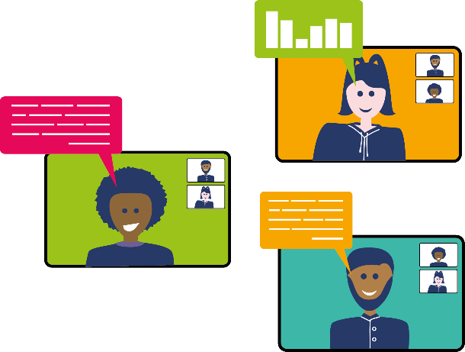
All resources can be accessed at https://www.dyw.scot/mastering-skills-for-virtual-working.html

Mapping to Health and Wellbeing Experiences and Outcomes:

Mental and Emotional Wellbeing
All Levels
I know that we all experience a variety of thoughts and emotions that affect how we feel and behave and I am learning ways of managing them. HWB 0-02a / HWB 1-02a / HWB 2-02a / HWB 3-02a / HWB 4-02a

I understand that there are people I can talk to and that there are a number of ways in which I can gain access to practical and emotional support to help me and others in a range of circumstances. HWB 0-03a / HWB 1-03a / HWB 2-03a / HWB 3-03a / HWB 4-03a

I understand that my feelings and reactions can change depending upon what is happening within and around me. This helps me to understand my own behaviour and the way others behave. HWB 0-04a / HWB 1-04a / HWB 2-04a / HWB 3-04a / HWB 4-04a

I understand the importance of mental wellbeing and that this can be fostered and strengthened through personal coping skills and positive relationships. I know that it is not always possible to enjoy good mental health and that if this happens there is support available. HWB 0-06a / HWB 1-06a / HWB 2-06a / HWB 3-06a / HWB 4-06a

I am learning skills and strategies which will support me in challenging times, particularly in relation to change and loss. HWB 0-07a / HWB 1-07a / HWB 2-07a / HWB 3-07a / HWB 4-07a

Planning for choices and changes
Early and First
I can describe some of the kinds of work that people do and I am finding out about the wider world of work. HWB 0-20a / HWB 1-20a

Planning for choices and changes
Second, Third and Fourth
I am investigating different careers/occupations, ways of working, and learning and training paths. I am gaining experience that helps me recognise the relevance of my learning, skills and interests to my future life. HWB 2-20a / HWB 3-20a / HWB 4-20a

I am developing the skills and attributes which I will need for learning, life and work. I am gaining understanding of the relevance of my current learning to future opportunities. This is helping me to make informed choices about my life and learning. HWB 3-19a

Any questions please contact info@dyw.scot.

